Bible Study – Daniel
Week 10 – Chapter 8

- Daniel 8:1-4

¹In the third year of the reign of Belshazzar the king a vision appeared to me, Daniel, subsequent to the one which appeared to me previously. ²I looked in the vision, and while I was looking I was in the citadel of Susa, which is in the province of Elam; and I looked in the vision and I myself was beside the Ulai Canal. ³Then I lifted my eyes and looked, and behold, a ram which had two horns was standing in front of the canal. Now the two horns were long, but one was longer than the other, with the longer one coming up last. ⁴I saw the ram butting westward, northward, and southward, and no other beasts could stand before him nor was there anyone to rescue from his power, but he did as he pleased and magnified himself.

- This dream probably occurred in 550BC. This is the same year that Cyrus established the Medo-Persian Empire.
- Nabonidus (co-regent) tried form an alliance with Lydia and Egypt to stand against the empire that Cyrus had forged. Of course, Lydia, Egypt, and Babylon were the nations pictured in the jaws of the 2nd beast from Chapter 7.
- He was still in Babylon, but in the vision, saw himself in the citadel (fortress) of Susa.
- The Ram symbolizes Medo-Persia, just like in chapter 7. The Persians would the more important and larger horn.
- No nation was able to oppose the Ram and it gained more territory than any nation previous to it in history.

- Daniel 8: 5-8

⁵While I was observing, behold, a male goat was coming from the west over the surface of the whole earth without touching the ground; and the goat had a conspicuous horn between his eyes. ⁶He came up to the ram that had the two horns, which I had seen standing in front of the canal, and rushed at him in his mighty wrath. ⁷I saw him come beside the ram, and he was enraged at him; and he struck the ram and shattered his two horns, and the ram had no strength to withstand him. So he hurled him to the ground and trampled on him, and there was none to rescue the ram from his power. ⁸Then the male goat magnified himself exceedingly. But as soon as he was mighty, the large horn was broken; and in its place there came up four conspicuous horns toward the four winds of heaven.

- Goat was the Greek empire.
- “Without Touching the ground” means it was quick in its conquests.
- The great horn was Alexander the Great. When he died, the four horns that appeared were the 4 generals that the Kingdom was left to.

- Daniel 8:9-14

⁹ Out of one of them came forth a rather small horn which grew exceedingly great toward the south, toward the east, and toward the Beautiful Land. ¹⁰It grew up to the host of heaven and caused some of the host and some of the stars to fall to the earth, and it trampled them down. ¹¹It even magnified itself to be equal with the Commander of the host; and it removed the regular sacrifice from Him, and the place of His sanctuary was thrown down.¹²And on account of transgression the host will be given over to the horn along with the regular sacrifice; and it will fling truth to the ground and perform its will and prosper.¹³Then I heard a holy one speaking, and another holy one said to that particular one who was speaking, “How long will the vision about the regular sacrifice apply, while the transgression causes horror, so as to allow both the holy place and the host to be trampled?” ¹⁴He said to me, “For 2,300 evenings and mornings; then the holy place will be properly restored.”

- The small horn here probably refers to the eighth ruler of the Seleucid Greek Empire, Antiochus IV Ephiphanes (175-163BC). He started off with nothing, but became a great ruler, even conquering Palestine.
- Palestine is the “Beautiful land” (Daniel 11:16 and Jeremiah 3:19). It is not called this because of any physical reason, but rather it is the center of God’s operations and earth, and the home of the Jews.
- “Threw some of the starry host down to the earth and trampled on them” – He persecuted the Jewish Saints. He assassinated the High Priest, Onias II and executed thousands of Jews.
- It even magnified itself to be equal with the Commander of the host – He declared that his gods were higher than Yahweh.
- Antiochus set up a statue of Zeus in the Temple of God and defiled the temple (The Abomination that causes desolation).
- Two views - The 2,300 evenings and mornings is a period of 1,150 days, as sacrifices were offered morning and night.The statue was set up in 167 BC and the temple was rededicated in December 164 BC by Judas Maccabeus (the Maccabees) – 3 years
- The 2,300 evenings and mornings were actually 2,300 days. The sacrifices would have stopped at the death of High Priest Onias II (170BC) and resumed in December 14, 164 BC – 6 months, 4 days.
- The Jews celebrate the Feast of Hanukkah (“dedication”) to commemorate December 14, 164 BC.

- Daniel 8: 15-19

¹⁵ When I, Daniel, had seen the vision, I sought to understand it; and behold, standing before me was one who looked like a man.¹⁶And I heard the voice of a man between the banks of Ulai, and he called out and said, “Gabriel, give this man an understanding of the vision.” ¹⁷So he came near to where I was standing, and when he came I was frightened and fell on my face; but he said to me, “Son of man, understand that the vision pertains to the time of the end.” ¹⁸Now while he was talking with me, I sank into a deep sleep with my face to the ground; but he touched me and made me stand upright. ¹⁹He said, “Behold, I am going to let you know what will occur at the final period of the indignation, for it pertains to the appointed time of the end.

- The “one who looked like a man” may have been God Himself
- This verse contains the first instance in Scripture where a holy angel is designated by name. Gabriel is a prominent angel, also appearing to Zechariah, who was the father of John the Baptist
- Daniel was afraid and fell on his face likely because of the presence of God, not fear of Gabriel.
- Time of the end’ is the general prophetic expression for the time which, as the period of fulfillment, lies at the end of the existing prophetic horizon—in the present case the time of Antiochus.

- Daniel 8:20-27

²⁰ “The ram which you saw with the two horns represents the kings of Media and Persia.” ²¹ “The shaggy goat represents the kingdom of Greece, and the large horn that is between his eyes is the first king. ²²“The broken horn and the four horns that arose in its place represent four kingdoms which will arise from his nation, although not with his power.²³“In the latter period of their rule, When the transgressors have run their course, A king will arise, Insolent and skilled in intrigue. ²⁴“His power will be mighty, but not by his own power, And he will destroy to an extraordinary degree And prosper and perform his will; He will destroy mighty men and the holy people. ²⁵“And through his shrewdness He will cause deceit to succeed by his influence; And he will magnify himself in his heart, And he will destroy many while they are at ease. He will even oppose the Prince of princes, But he will be broken without human agency.²⁶“The vision of the evenings and mornings Which has been told is true; But keep the vision secret, For it pertains to many days in the future.” ²⁷Then I, Daniel, was exhausted and sick for days. Then I got up again and carried on the king’s business; but I was astounded at the vision, and there was none to explain it.

- Toward the end of the Greek rule was when Antiochus would come to power and those that rebelled against God would be punished.
- “not by his own power” means that God raised Antiochus up for His purposes
- God gave Daniel a vision of the more immediate future for Israel.
- Daniel while old, was still doing the King’s business. Since Belshzzar did not know him, it may have been that he was working for Nabonidus

- Something To Think About (Current Events)
There is a cryptic reference to Satan in Revelation 2:12-13, which demands our attention…
And to the angel of the church in Pergamum write: The One who has the sharp two-edged sword says this: ‘I know where you dwell, where Satan’s throne is; and you hold fast My name, and did not deny My faith even in the days of Antipas, My witness, My faithful one, who was killed among you, where Satan dwells.
The Alter of Zeus was built in the second-century BC, not as a temple, but as an open-air alter.
Eumenes II, king of Pergamos, was probably the one who built it. He was the person who appointed Antiochus IV Epiphanes as king of the Seleucid Syrian Empire.
Antiochus IV went to Pergamos and worshiped at the Alter of Zeus
Fast forward about 2000 years…
“The German archeologists are in Pergamum. They approach the Muslim Ottoman rulers with a proposal to buy this old pagan alter to Zeus, and move it to – Berlin. They moved the entire edifice to Berlin, where they built a massive museum in the 1880’s, and restored the alter. It became quite famous and an icon of Greek architecture, recognized by ‘educated’ people around the world.”
Fast forward again about 50 years…
Hitler built an outdoor replica from which he gave a series of mesmerizing speeches to the assembled masses. It was a coming out party of a sort, where the world realized this was no ordinary politician. He seemed imbued with an almost hypnotic ability to say nothing in particular, but in a way which enraptured the youth.
And he did it while speaking from Berlin’s most famous ancient museum piece: The Great Alter of Pergamum, a.k.a. – The alter of Zeus a.k.a. – the throne of Satan.”
“Another charismatic young politician mesmerizes huge German crowds with a rousing speech in Berlin.
So did Barack Hussein Obama visit the Museum of the Great Alter of Zeus in Berlin while he was there? Yes

He made a bold, and some would say arrogant, decision to accept his party’s nomination in a massive football stadium, hoping to fill it up with 100,000 fans. The numbers were unprecedented for an American political speech.

He wanted to give a speech from a replica of a Greek building – The Great Alter of Zeus!
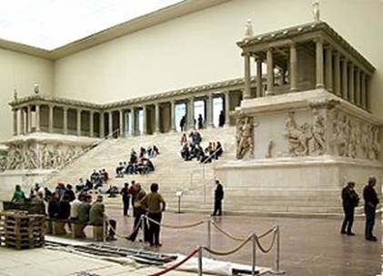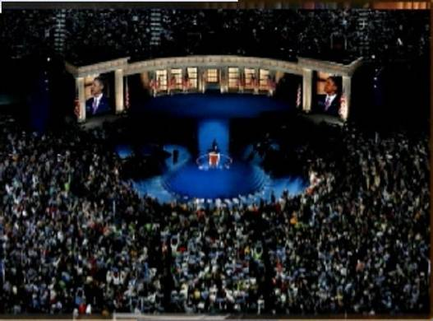

What is not well known is Satan also had a “chariot”. And his “charioteer” was none other than “Victoria”, also known as “The Goddess of Victory”. (photo above)
As an aside note, in the 1880’s, archeologists removed the “altar” from Pergamos and painstakingly reassembled it in Berlin where it is now today in a special museum built to ‘encapsulate it’ for display and preservation.
A statue of “Victory” stands high atop a Grecian spire which is very reminiscent of the ancient Egyptian obelisks.
Now what is fascinating is when Barack Obama went to Berlin and gave his speech on ‘foreign policy’.
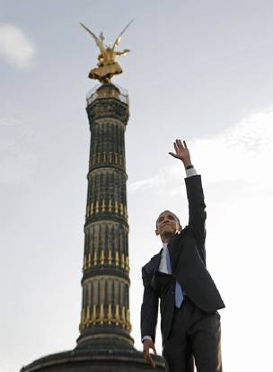
Before he became the alleged President of the United States in the summer in 2008, he stood beneath this statue of “Victoria” and spoke to the tremendous crowds assembled there.
He did not ‘directly face the crowds’ while giving his speech, but instead, made it a point to stand to the ‘left of the crowd’, having them to his ‘right’.
By doing this he had positioned himself to face directly toward, and address, the Museum in Berlin where the “Altar of Zeus” is
now located, while at the same moment standing beneath Satan’s Charioteer “Victoria”…
“Victoria”, while driving Satan’s “Chariot”, can be found in all her glory, high above the Brandenburg Gate in Berlin Germany.
Here she is displayed majestically, in total command and mastery of Satan’s personal chariot, while driving forward his mighty steeds of ‘renown’ … the “Four Horses of the Apocalypse.”
